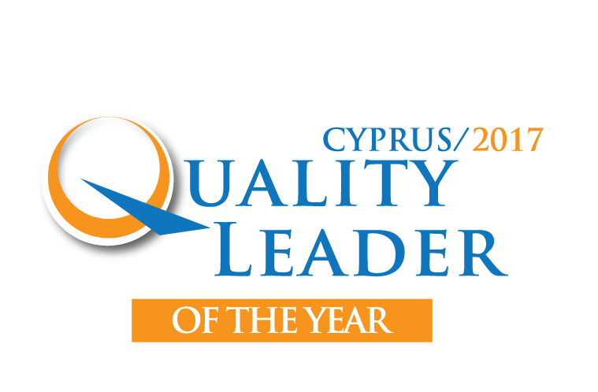

Your main professional achievements:

Your leader skills (with examples of application) of:

- Setting directions
- Demonstrating personal character
- Building organizational capability
- Mobilizing individual commitment

Application form

Name: First name:

Address:

Tel: Mobile:

e-mail:

Application form

Factual recognition (Co-workers, collaborators, management, social….):

Factual results of your best achievement (success story):
- Objectives attained
- Relevant results/effects (for customers, employees, organization, investors, environment, society, etc.
- European and/or international extension of your achievement
- Your own contribution
- Lessons learned

Maximum 5 pages. Please send this filled-in form together with your CV
at mgregoriou@oeb.org.cy by November 30, 2017

