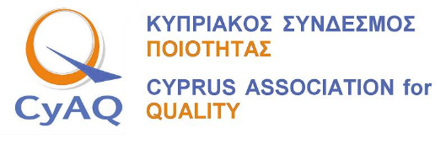
Cyprus Quality Leader of the Year 2021
CV Form

Personal information
First name(s) / Surname(s)
Address
Telephone(s) |  | Mobile:
E-mail
Nationality
Date of birth
Gender
Work experience
 | Add separate entries for each relevant post occupied, starting from the most recent
Dates
Occupation or position held
Main activities and responsibilities
Company/Organization Name
Type of business or sector
Work experience
Dates
Occupation or position held
Main activities and responsibilities
Company/Organization Name
Type of business or sector
Work experience
Dates
Occupation or position held
Main activities and responsibilities
Company/Organization Name
Type of business or sector
Education and training
 | Add separate entries for each relevant course you have completed, starting from the most recent
Dates
Title of qualification awarded
Principal subjects/occupational skills covered
Name and type of organisation providing education and training
Level in national or international classification
Dates
Title of qualification awarded
Principal subjects/occupational skills covered
Name and type of organisation providing education and training
Level in national or international classification
Dates
Title of qualification awarded
Principal subjects/occupational skills covered
Name and type of organisation providing education and training
Level in national or international classification
Personal skills and competences
Social skills and competences
Organisational skills and competences
Technical skills and competences
Publications | Include here relevant kind of publication, title, year, language
Outstanding achievements | Include here successful quality improvement and/or change projects lead by you in the last 3 years
Date:

